<http://www.forbes.com/sites/abinlot/2015/05/15/wolfe-von-lenkiewicz-channels-picasso-in-upper-east-side-exhibition/#45fdfad76d29>

* **LOG IN**

#### YOUR READING LIST

### COVER STORY[Forbes 400: Immigrants](http://www.forbes.com/sites/monteburke/2016/10/04/6-immigrant-stories-that-will-make-you-believe-in-the-american-dream-again/)

* [Most Popular](http://www.forbes.com/most-popular/)
* [New Posts](http://www.forbes.com/real-time/)

## Comment Now

## on Wolfe Von Lenkiewicz Channels Picasso In Upper East Side Exhibition

Начало формы

Please [**log in**](http://blogs.forbes.com/account/login) or [**sign up**](http://blogs.forbes.com/account/register) to comment.

* 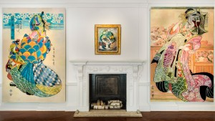

### [Wolfe Von Lenkiewicz Channels Picasso In Upper East Side Exhibition](http://www.forbes.com/sites/abinlot/2015/05/15/wolfe-von-lenkiewicz-channels-picasso-in-upper-east-side-exhibition/" \t "_self)

**MAY 15, 2015 @ 07:18 PM 1,362 VIEWS**[**The Little Black Book of Billionaire Secrets**](http://bit.ly/29fF72b)

# Wolfe Von Lenkiewicz Channels Picasso In Upper East Side Exhibition

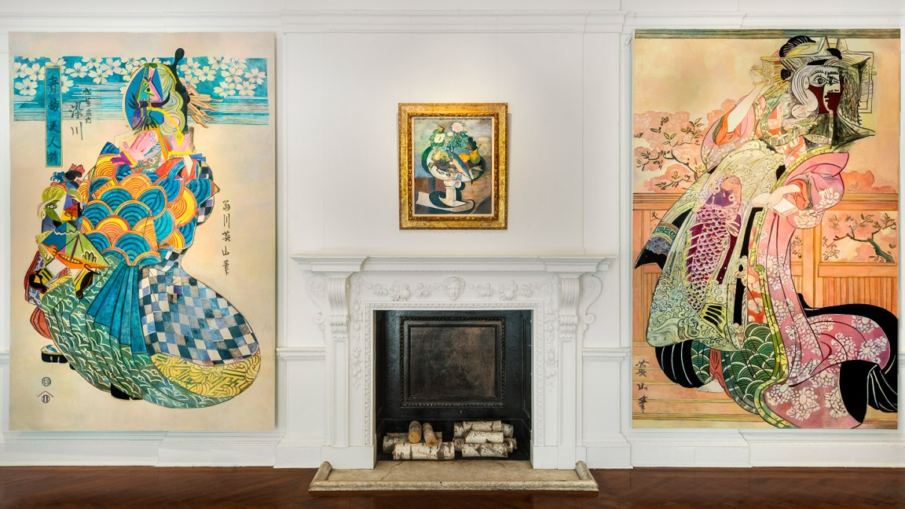

**CONTRIBUTOR**

*I bring creativity and culture from around the globe to you.*

Opinions expressed by Forbes Contributors are their own.

The large-scale paintings of British artist Wolfe von Lenkiewicz made their U.S. debut this week in New York’s Upper East Side. Set against the backdrop of the magnificent Academy Mansion on East 63rd Street, Von Lenkiewicz’s paintings make the perfect pairing to the home William Ziegler Jr. built in 1921.

Organized by [House of the Nobleman](http://www.houseofthenobleman.com/) — the multi-platform organization helmed by Victoria Golembiovskaya and Anastasiya Siro that encompasses an art advisory, curatorial practice and private dealership — along with Mark Sanders Art Consultancy, the exhibition, titled [*Delirious Picasso*](http://houseofthenobleman.com/upcoming-exhibition-delirious-picasso.html) after Von Lenkiewicz’s inspiration Pablo Picasso — whose Les Femmes d’Alger (Version O) broke auction records when it sold for $179 million at Christie’s earlier this week — and the manifesto Delirious New York written by Rem Koolhaas in 1978, took over four floors of the mansion, making for a spectacular display of art and grandeur.

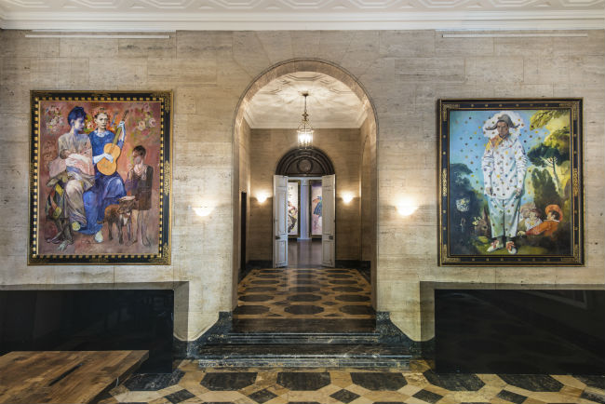

*Les Saltimbanques and Pierrot by Wolfe von Lenkiewicz in the foyer of Academy Mansion (Andy Romer Photography)*

For the exhibition, which is on view through the weekend, Von Lenkiewicz took his fascination with Pablo Picasso, Japanese artist Kikugawa Eizan, and ukiyo-e, a Japanese genre and paintings, and reappropriated the imagery on to enormous canvases. In the mansion’s foyer hangs Les Saltimbanques, an ode to Picasso’s harlequin period, and Demoiselles d’Avignon, a reinterpretation of Picasso’s famous painting fused with African masks. Further along into the exhibition is a Von Lenkiewicz’s remixes of practically every stage of Picasso’s career, from a Picasso head, to the Spanish painter’s still lifes. Thepièce de résistance of the exhibition is no doubt Giants, the enormous painting that depicts a battle between Japanese warriors and Picasso like characters that takes up an entire wall on the fourth floor.

РЕКЛАМА

[inRead invented by Teads](http://inread-experience.teads.tv/)

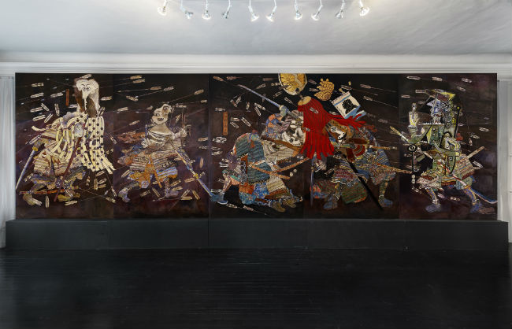

*Giants by Wolfe von Lenkiewicz (Andy Romer Photography)*

The exhibition also features works by Picasso himself, like a 1948 oil-on-canvas still life titled Tranche de Melon, a 1914 collage named Verre et carte a jouer, several etchings from the late ‘60s depicting nude women that Picasso apparently created during his impotent years. Additionally, Delirious Picasso takes a glimpse at other artists who were influenced by the Spanish artist, in particular Andy Warhol, whose ‘80s collages are on display, and Richard Prince, who, like Von Lenkiewicz reappropriated the figures and imagery used in Picasso’s oeuvre.

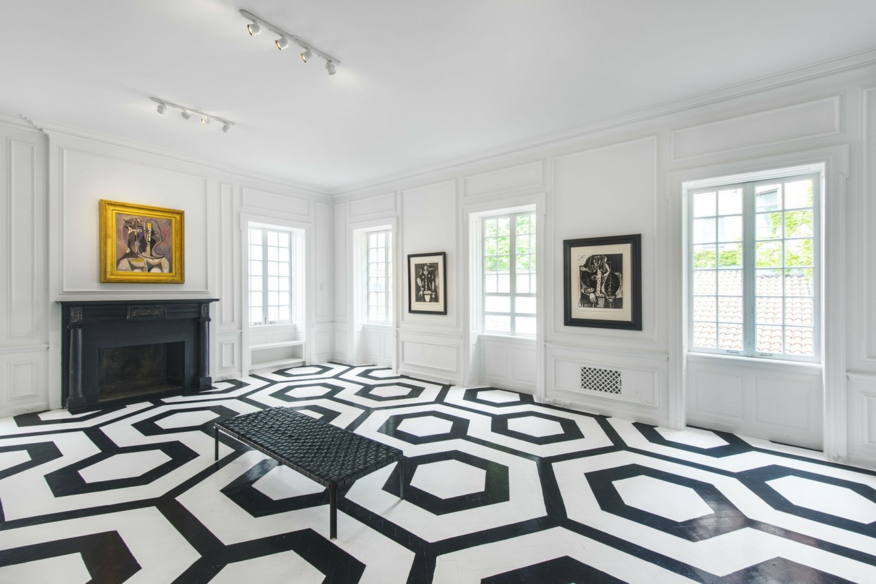

*(Andy Romer Photography)*

[***Delirious Picasso***](http://houseofthenobleman.com/upcoming-exhibition-delirious-picasso.html)**is on view at the Academy Mansion through May 17.**

**Comment on this story**

* [**Print**](http://www.forbes.com/sites/abinlot/2015/05/15/wolfe-von-lenkiewicz-channels-picasso-in-upper-east-side-exhibition/print/)
* **Report Corrections**
* [**Reprints & Permissions**](http://forbesreprints.magreprints.com/)

Ads by Revcontent

http://serve.revcontent.com/assets/img/adchoices_icon.png