<http://www.artspace.com/magazine/news_events/exhibitions/delirious-picasso-52818>

## [EXHIBITIONS](http://www.artspace.com/magazine/news_events/exhibitions)

# Picasso Among the Geishas: A New Show Transports the Record-Shattering Modernist to Edo-Period Japan

By [Andrew M. Goldstein](http://www.artspace.com/magazine/author/andrew-m-goldstein)

MAY 12, 2015

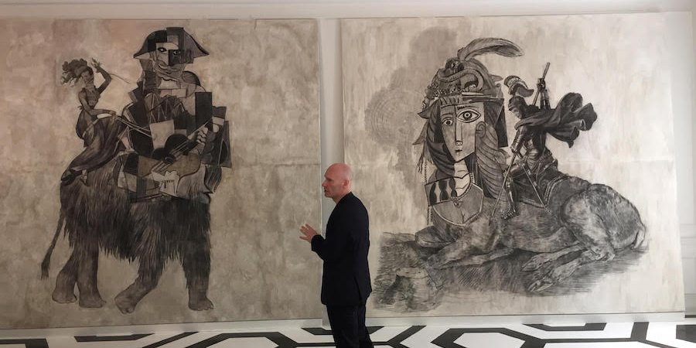

The artist Wolfe von Lenkiewicz with two of his paintings in "Delirious Picasso."

In 1920, the baking-powder heir **William Ziegler Jr.** built a magnificent mansion steps away from Central Park on East 63rd Street for himself and his wife, **Gladys**, but only lived there a year before his sudden divorce forced him to liquidate the property. The building then passed into the hands of the**New York Academy of Sciences**—from which it gets its sobriquet “the Academy Mansion”—and then, in 2005, to the billionaire Russian art collector **Leonard Blavatnik**. Now, the extraordinary space has been given over to a new exhibition curated by the enterprising duo **Anastasiya Siro** and **Victoria Golembiovskaya** (and co-curator **Mark Sanders**), who go by the moniker **House of the Nobleman**. The show's theme nods to the building's early history, although it's not a divorce but rather a happy May-December marriage.

The twist is that the May ingenue in this case is [**Pablo Picasso**](http://www.artspace.com/pablo_picasso), and the hale December spouse is the Japanese art of the Edo period.

Specially commissioned from the British artist [**Wolfe von Lenkiewicz**](http://www.artspace.com/wolfe_von_lenkiewicz), a technical whiz whose mashups of classic paintings make for delightful pop art-history quizzes, the artworks that dominate the show fuse instantly recognizable ‘samples’ from Picasso’s oeuvre with paintings done in the style of the geisha portraitist **Kikugawa Eizan** and other 19th-century icons. There are also several sprightly  takes on the Andalusian master by [**George Condo**](http://www.artspace.com/george_condo) and [**Richard Prince**](http://www.artspace.com/richard_prince), together with several small works on paper and a collage by Picasso himself. The title of the show is “Delirious Picasso,” and it fits the fun-house feel of the installation (in which several pieces span entire walls).

The show, von Lenkiewicz explains, was inspired by Picasso’s own complicated relationship with Japanese art. Whereas his fellow Moderns like **Matisse** and **Odilon Redon** were early adopters ofJaponisme, Picasso in his typically against-the-grain manner rejected any interest in the work—even brusquely telling **Gertrude Stein** in one of their first meetings to put away a set of ukiyo-e prints she profferred him. In his later years, however, when he was working on his last great series of randy etchings (the "347 Series"), the artist finally acquired 63 of these erotic Japanese prints for himself.

Von Lenkiewicz sees his work as celebrating this deep-running sympathy, although, as he says, “It's not really about Picasso and it's not really about Japan. It's about how we compose our own histories.” And in fact, other artists peek in around the edges. Some of the paintings incorporate clear references to the styles of such diverse artists as **Watteau**, **Sigmar Polke**, **Walt Disney**, **Chagall**, and **Augustus John**, whom Picasso called “the best bad painter in England.” (Cineastes might also know John as the inspiration for **Alec Guinness**’s dissolute artist in the 1958 film The Horse’s Mouth.)

The timing of “Delirious Picasso” is fortuitous; it opens in the wake of **Christie’s** astonishing—and, yes, delirious—sale of the artist’s 1955 painting Les Femmes d’Alger (Version ‘O’) for $179 million, a world record for any work of art at auction. That sale (organized by the market revolutionary **Loic Gouzer)** placed the painting square in the middle of a contemporary art auction, in its way arguing for his continuing agency in the current moment, and “Delirious Picasso” does too. Of course, our Malagan friend doesn’t really need help on that front, as any working artist would tell you. In case you were wondering, all of the works in the exhibition—sourced from **Galerie Michael Haas** in Berlin and private collections, or made out on Long Island, as Von Lenkiewicz’s were—are for sale, with two of the Picassos in the $1.5 million range.

Below, see a sampling of artworks from “Delirious Picasso.”

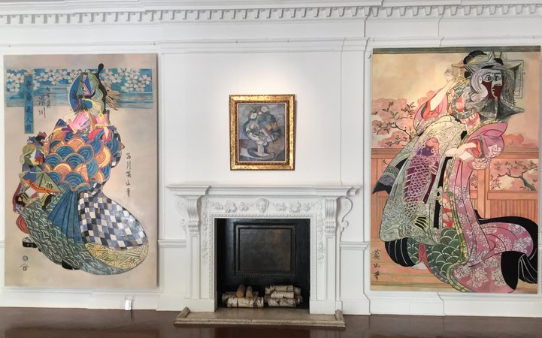

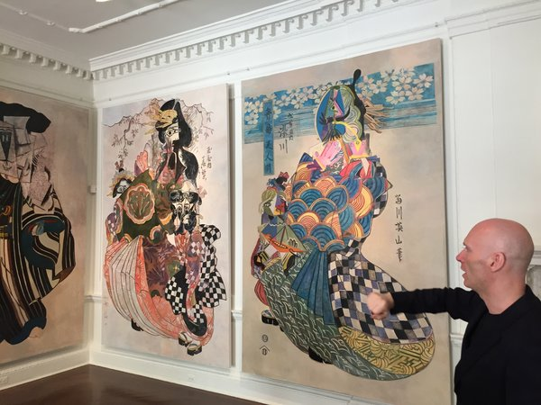

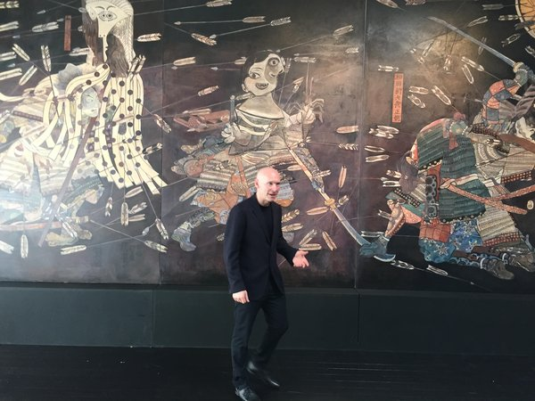

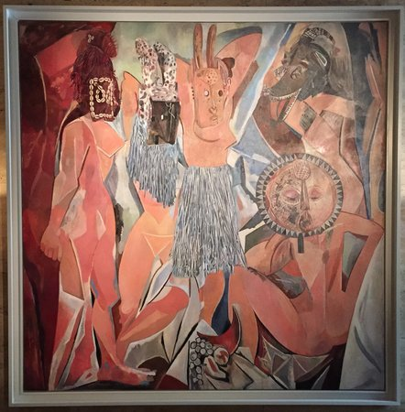

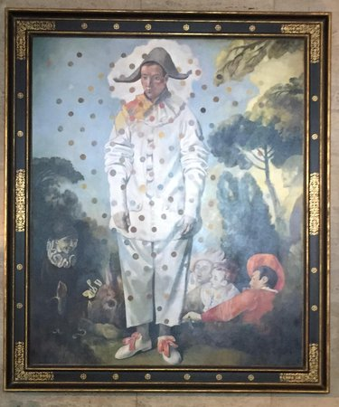

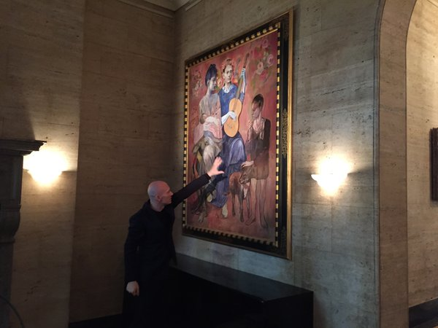

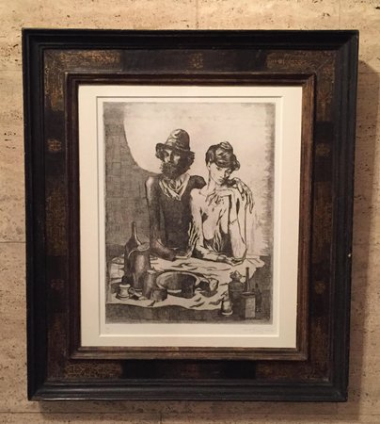

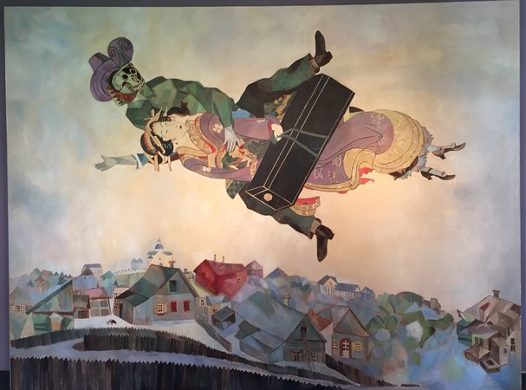

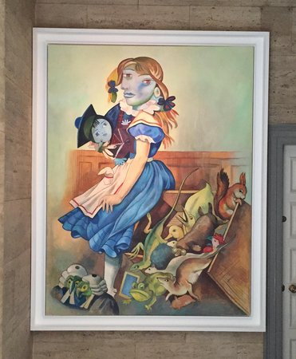

A few Picassos:

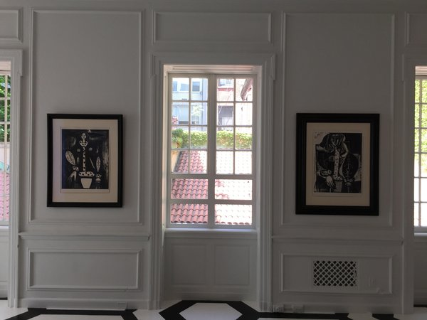

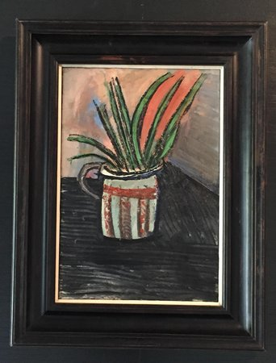

A Condo:

